Pizza

- Create Table Query
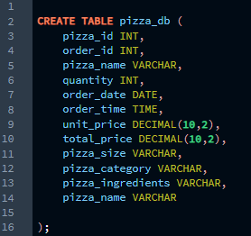

- Import csv file in db
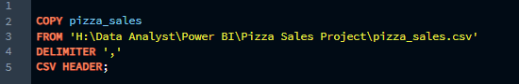

KPI
- Total Revenue
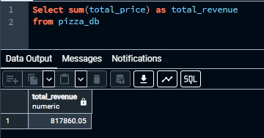
- Average Order Value
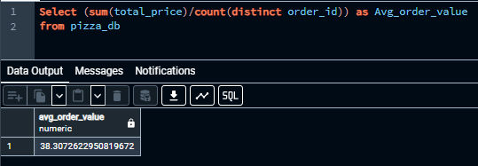

- Total Pizza Sold
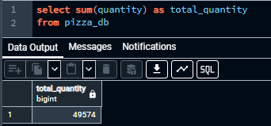

- Total Order Placed
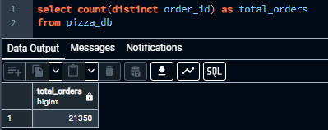
- Average Pizzas Per Order

Charts
- Total order per day (Daily Trend)
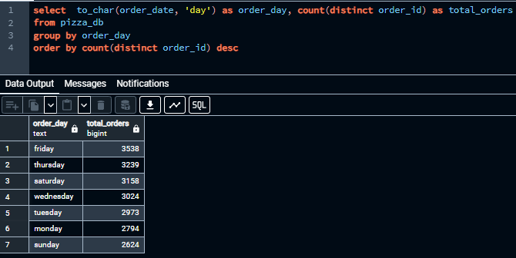
- Total order per month (Monthly Trend)
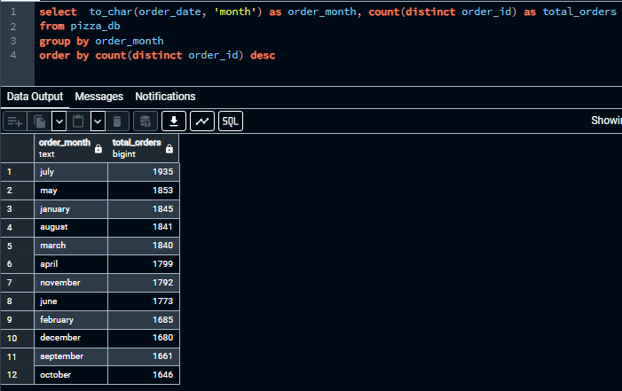

- Percentage of sales by pizza category
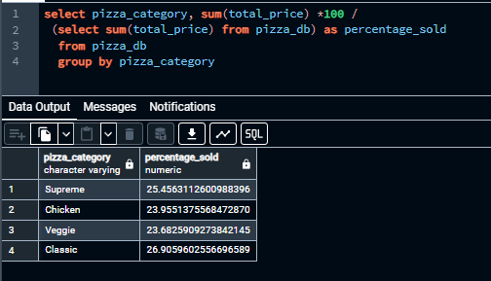

- Percentage of sales by pizza size.
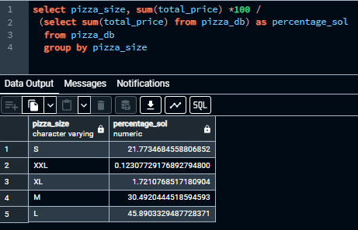
- Top 5 best sellers by Revenue
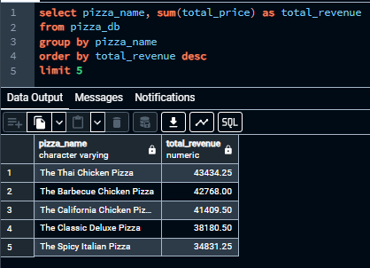
- Bottom 5 sellers by Revenue
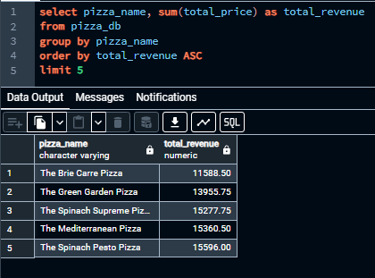
- Top 5 best sellers by total quantity
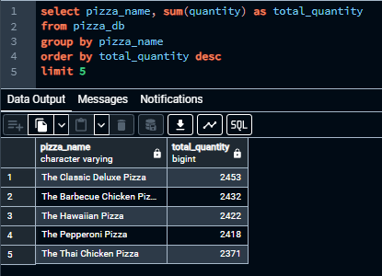
- Bottom 5 best by total quantity
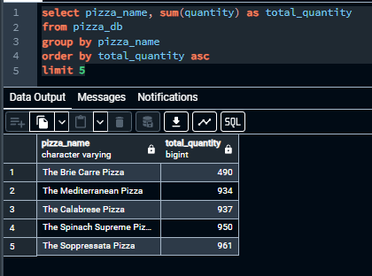

- Top 5 best sellers by total orders
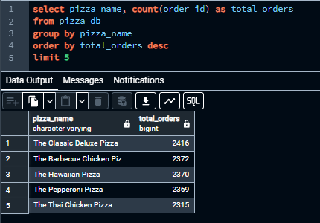
- Bottom 5 sellers by total orders
